# Test File

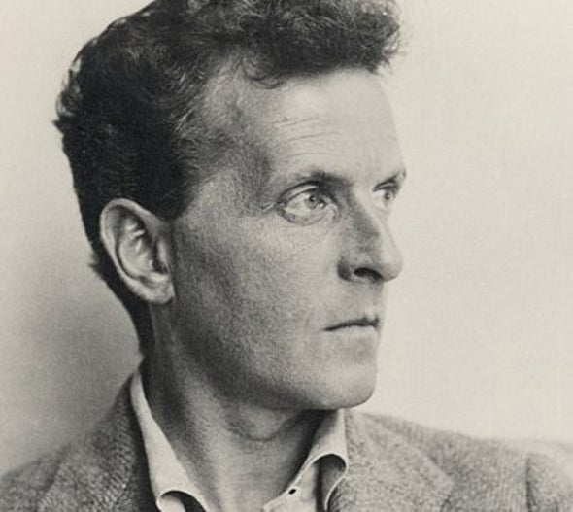

This file is used to test upgrades to **xslt-for-docx**.

It includes footnotes,[1] endnotes[2], an image, and extended Unicode points.

AѼ㫜

1. <https://github.com/Arithmeticus/xslt-for-docx>
2. Here is an endnote.